# [https://avatars2.githubusercontent.com/u/4156894?v=3&s=100](http://www.calstatela.edu/centers/hipic) BUS5100 Term Project Tutorial

#### Authors: [Jennifer Knowles](https://www.linkedin.com/in/jknowles1);  [Darlena Robinson](https://www.linkedin.com/in/darlenarobinson);  [Jazmine Miramontes](https://www.linkedin.com/in/jazmine-miramontes-9b3bb3194);  [Diego Contreras](https://www.linkedin.com/in/diego-contreras-a504666b)

#### Instructor: [Jongwook Woo](https://www.linkedin.com/in/jongwook-woo-7081a85)

#### Date: 03/30/2025

**Lab Tutorial**

Jennifer Knowles ([jknowle7@calstatela.edu](mailto:jknowle7@calstatela.edu)), Darlena Robinson ([drobin38@calstatela.edu](mailto:drobin38@calstatela.edu)), Jazmine Miramontes ([jmiramo5@calstatela.edu](mailto:jmiramo5@calstatela.edu)), Diego Contreras ([dcontr115@calstatela.edu](mailto:dcontr115@calstatela.edu))

03/30/2025

**Los Angeles Open Data Analysis using**

**SAP Analytics Cloud** 

**(Foreclosures in Los Angeles County, CA)**

**Objectives**

In this hands-on lab, you will learn how to:

1. Get data manually by downloading foreclosure data from <https://data.lacity.org> (Los Angeles Open Data) – the Los Angeles Housing Authority’s data.
2. Data Wrangle the imperfect government data
3. Create SAP Dataset
4. More data wrangling in the SAP Model
5. SAP Story Visualization

**Platform Spec**

* SAP Analytics Cloud
* CPU Speed: Base: 1.90 GHz
* # of CPU cores: 14
* # of nodes: did not learn in this course
* Total Memory Size: 3MB

Step 1: Get data manually using Los Angeles Open Data

This step is to get data manually six (6) Excel CSV files to perform data wrangling in the next step.

1. Retrieve the Foreclosure Data for years **2019 to 2024** from the Housing Authority’s website: [https://data.lacity.org](https://data.lacity.org/browse?sortBy=relevance&pageSize=20&limitTo=datasets&q=foreclosure).
2. The link takes you to the following landing page. Click on the “**2019 Registered Foreclosure Properties**” link.

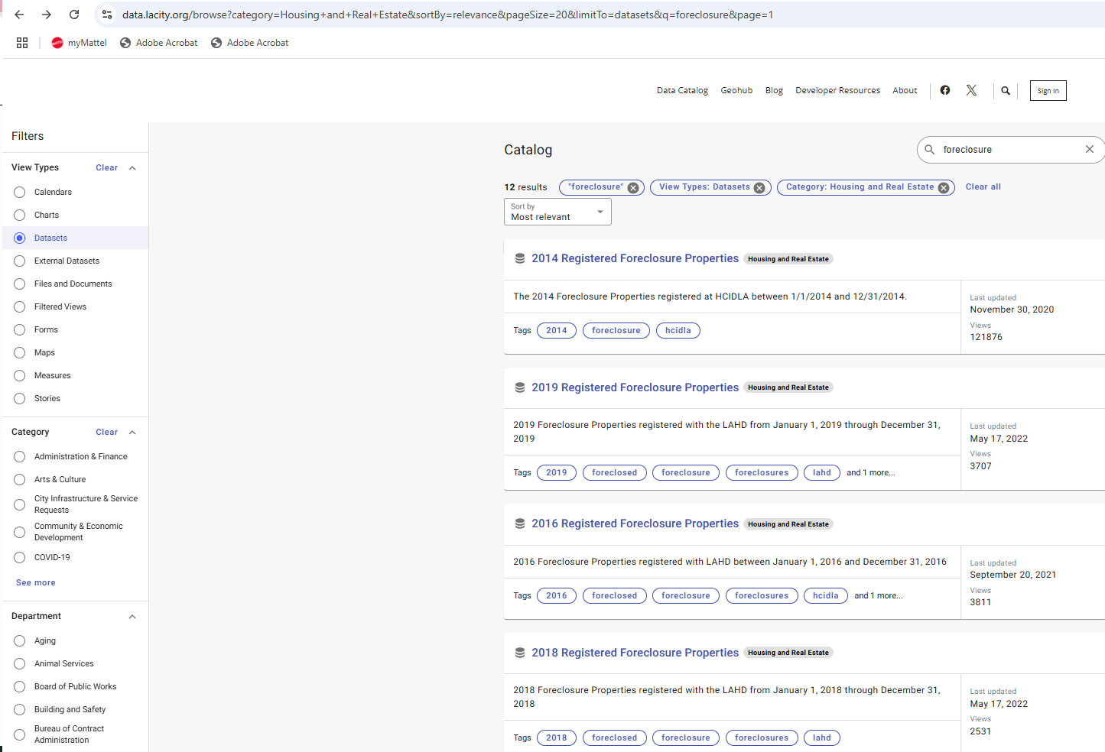

Figure 1.1 LA Housing Authority Foreclosure landing page.

a) Below is a closer look at what you should select.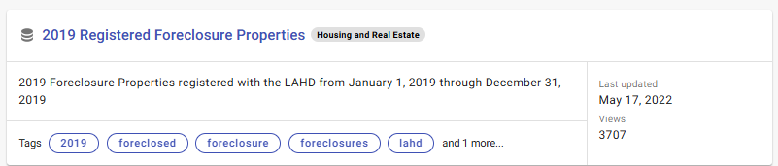

Figure 1. 2

b) The landing page of the export report looks like figure 2 below. Hit Export on the top right corner of the landing page. 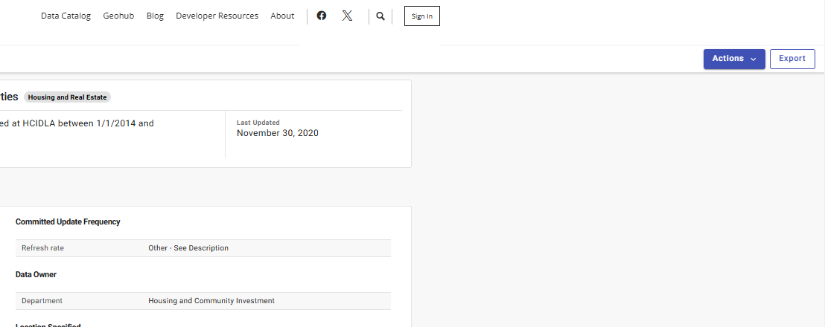

Figure 1. 3

c) A popup window appears, and it defaults to a “CSV” export format. Click on the dropdown menu to select “CSV for Excel.”

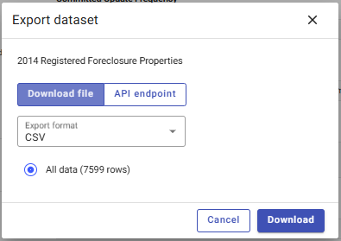

Figure 1. 4

d) Click download. You should find the **2019** Excel CSV file in your device’s Downloads folder.

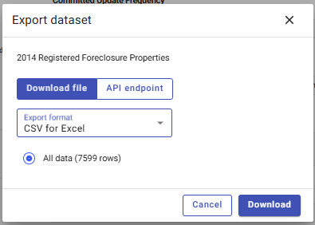

Figure 1. 5

1. Repeat this process a) through d) for **2020, 2021, 2022, 2023, and 2024** annual files.
2. Your download folder should look like the following and you should see Excel Comma Separated Values as your file type: 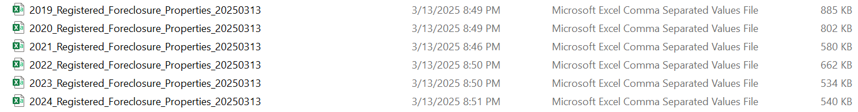

Figure 1. 6

Step 2: Data Wrangling the Housing Authority’s Data

This step is to wrangle the data (clean, edit, correct, delete). SAP SAC Modeler cannot combine the data as-is because we learned this during our testing phases. **No coding is required.**

1. Manually consolidate the data from the **six** (6) Excel CSVs into **ONE** Excel CSV.
2. Copy and paste data from all of the 2021 – 2024 Excel CSVs into the 2019 Excel CSV. It is a pain, but you do have to manually consolidate this data.
3. This will become the main file after all the other Excel CSVs are added to it. You should rename the file to something like what we created: “***FILE_LACounty_Foreclosures_2019-2024_Clean***” so that someone does not think only 2019 data is in the file.
4. Consolidation Steps:
   1. Select row 2
   2. Hit these keys at the same time: *CTRL* +*SHIFT* + *DOWN ARROW*
   3. Hit keys CTRL + C (Copy)
   4. Go to the consolidation file and go to the last row of the data by hitting keys *CTRL + DOWN ARROW*
   5. Paste or *CTRL + V* in the cell in column A in the row beneath the last row of data in the consolidation file as depicted below.

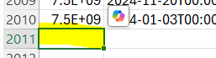

Figure 2. 1

|  |  |
| --- | --- |
| **The upload file should have 14,828 rows:** | |
| 2019 had 3,317 rows of data and now has 3,284 rows | 2020 has 2,977 rows |
| 2021 has 2,114 rows | 2022 has 2,416 rows |
| 2023 has 2,066 rows | 2024 had 2,009 rows of data and now has 1,971 rows |

1. Change the Registered Date
   1. The original date has the time attached to it. You can remove the time, by finding and replacing the time or “12:00:00 AM” (including the space) to manually trim the data down to just include the short date in column B.

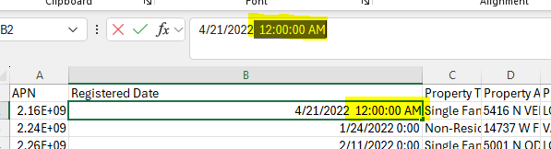

Figure 2. 2

* 1. Hit these keys at the same time: CTRL +SHIFT + DOWN ARROW
  2. Hit keys CTRL + C (Copy)
  3. The 2014 file date looks like the following. Find and replace the “T00:00:00.000” from column B.

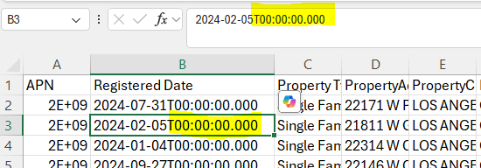

Figure 2. 3

1. Remove the Non-Residential Property Type
2. Apply a filter to the data

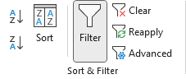

Figure 2. 4

1. Filter on **column C** – Property Type and select only the Non-Residential Property.

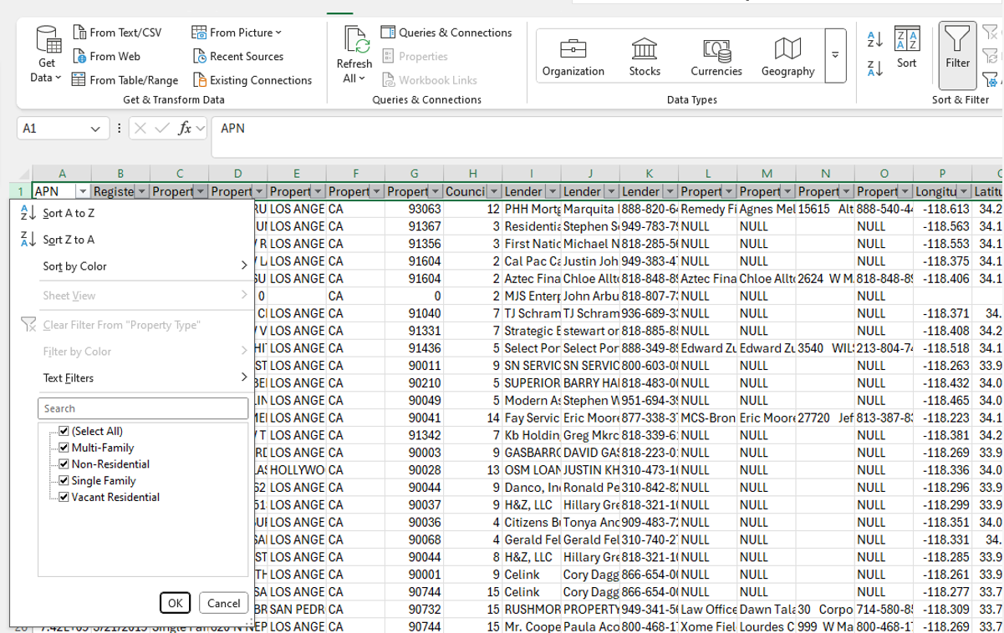

Figure 2. 5

1. Delete the rows of the filtered **Non-Residential** data. Right click the mouse and select “delete rows”
2. Clear the filter.



Figure 2. 6

1. Save the Excel upload file.
2. Data wrangle columns **A:G**
3. Insert two columns before column A in the consolidated 2019-2024 file. The new columns are A & B.
4. Insert one column before column E; it becomes column D.
5. **Insert two columns** after Registered Date column E

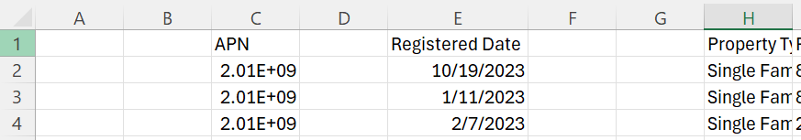

Figure 2. 7

1. Name column A “Count” and name column B “Year”
2. Name column D “Month Name”
3. Select column E

Figure 2. 8

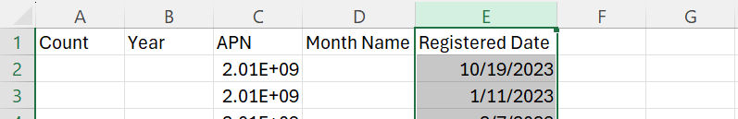

1. Go to the data top ribbon menu. Hit “Text to Columns” icon under Data Tools.

Figure 2. 9

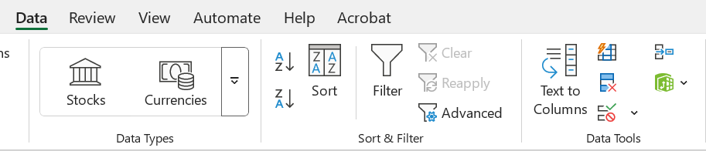

1. Select **Delimited** Original data type. Click on “**Next >”** button.

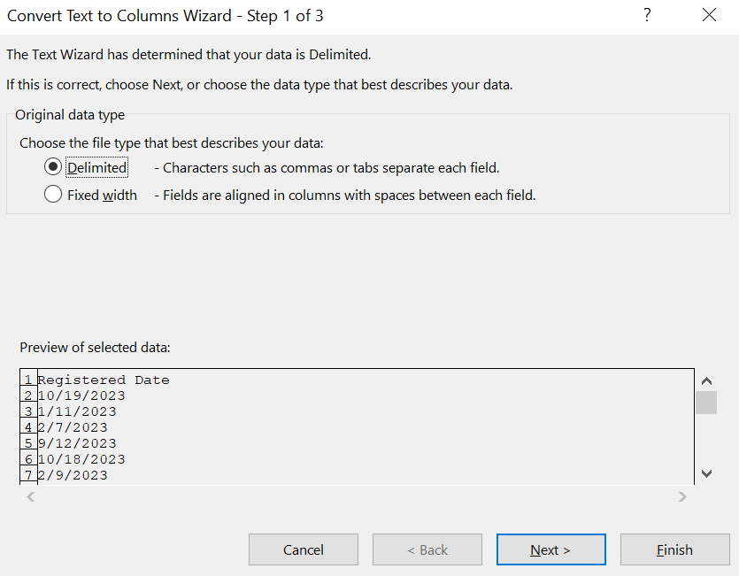

Figure 2. 10

1. Enter a “ **/** “ in the Other delimiter. Your Data preview should look like the window. below. Click on “**Next >”** button. 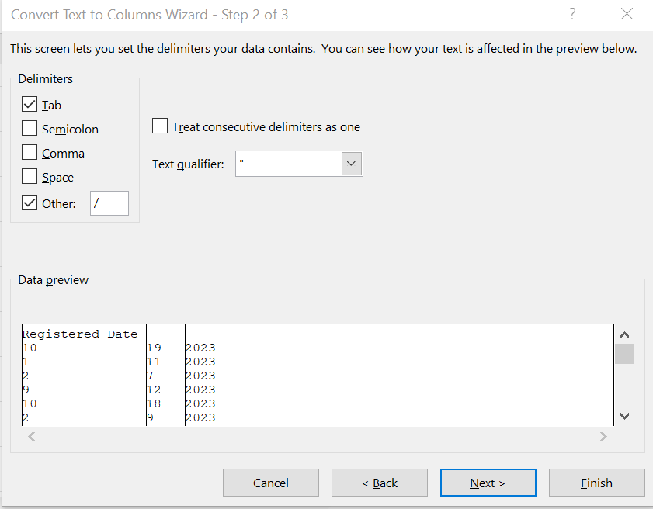

Figure 2. 11

1. Keep the Colum data format at **Text**. Click on **Finish**. 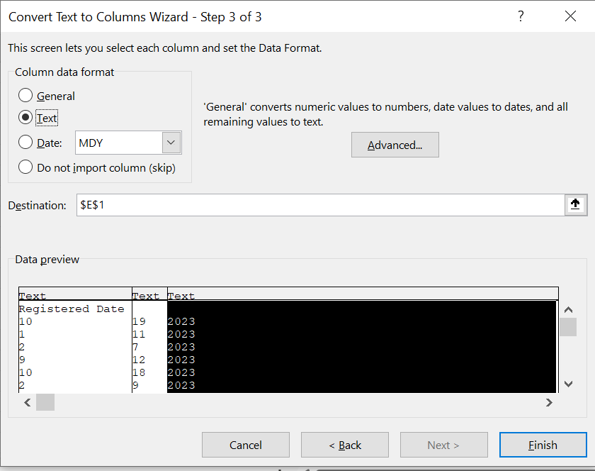

Figure 2. 12

1. After you hit Finish, your sheet will look like the following with green triangles in top left corner in each cell.

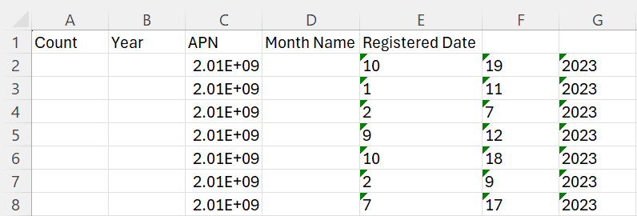

Figure 2. 13

1. We need to convert the text to numbers. Hold the SHIFT button while selecting columns cells E2:G2.

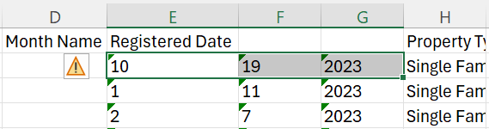

Figure 2. 14

1. Hold the CTRL + SHIFT + DOWN ARROW buttons at the same time. This will select all cells beneath the row until it reaches the end of the data at the very bottom.

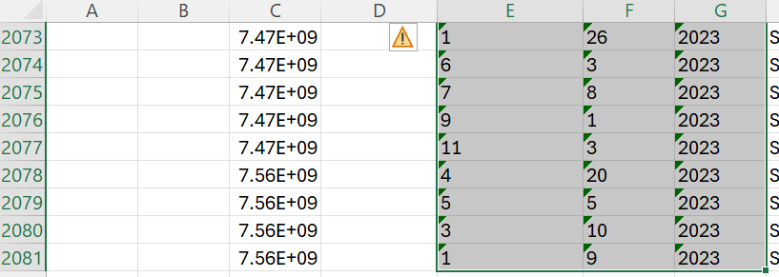

Figure 2. 15

1. Click on the yellow warning triangle. Select “Convert to Number” from the resulting drop-down menu.

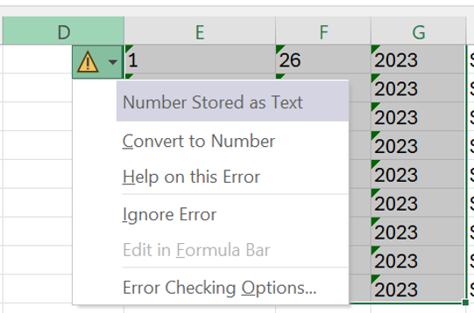

Figure 2. 16

1. Rename columns E:G “Month,” “Day,” and “Year” – in that order

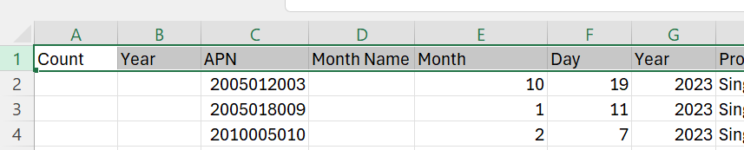

Figure 2. 17

1. Data wrangle column **D – add Month Name**
2. Add a new Sheet1by clicking on the “+” at the bottom right of tab name. 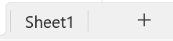

Figure 2. 18

1. Add a “LOOKUP” table for the Month Name VLOOKUP formula in the next step. Make it look like this:

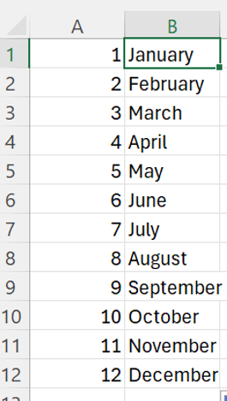

Figure 2. 19

1. Go back to the main consolidated data tab and **add the following entries accordingly:**

|  |  |  |
| --- | --- | --- |
| Column | Row | Enter |
| A | 2 | the number “**1**” |
| B | 2 | the formula **“=G2**” |
| D | 2 | The formula “**VLOOKUP(E2,Sheet1!$A$1:$B$12,2,FALSE)**” |

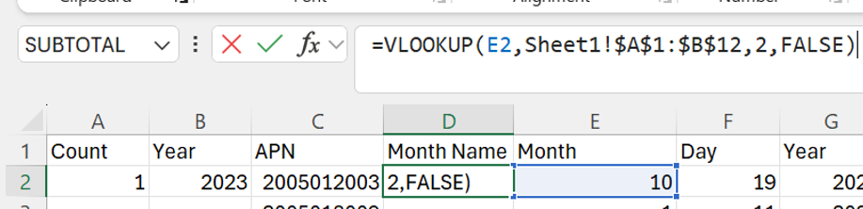

Figure 2. 20

1. AUTOFILL the data in each cell
2. Hover the pointer over the bottom right-hand corner of **cell D** until a **“+”** appears and drag the cell contents from **row 2** down to the very end of the data at the bottom. **NOTE: The FASTER WAY: is to hover over bottom right corner, find the “+” sign and double click on it.**

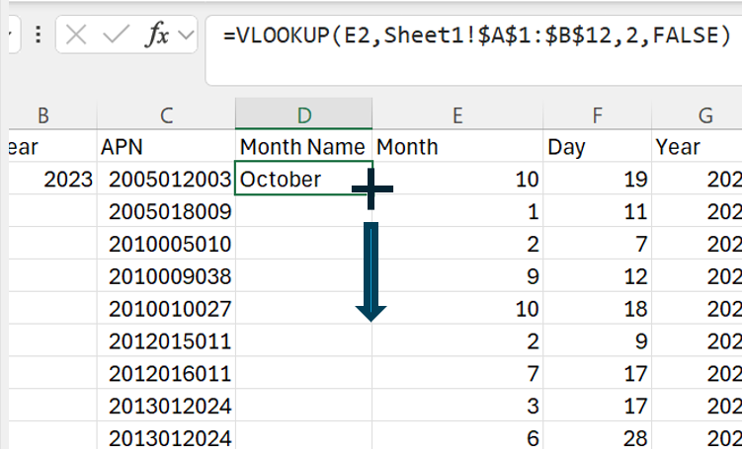

Figure 2. 21

**Double-click the mouse at the “+”**

1. For the contents of **Columns A, B, and D**: Copy (CTRL + C) and paste value (click on the paste icon and a dropdown appears for you to select the paste values icon)

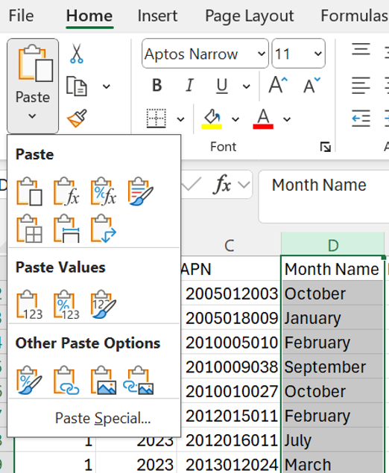

Figure 2. 22

1. The dataset result looks like the following for columns **A:G**

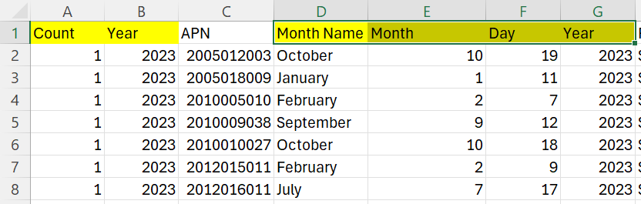

Figure 2. 23

1. Data wrangle columns **O:T – remove the columns**
   * 1. We don’t need any Property Management data and only need the Lender Name.
     2. Select the columns **O:T.**
     3. You are removing the columns: O:T: Lender Contact, Lender Contact Phone, Property Management, Property Management Contact, Property Management Address, Property Management Contact Phone (see list below).

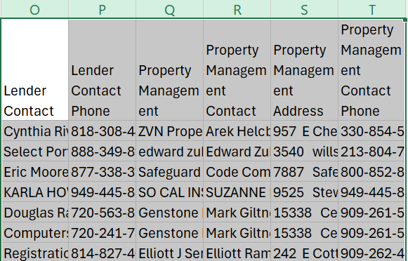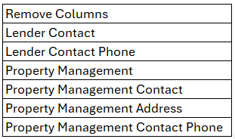

Figure 2. 25

Figure 2. 24

* + 1. Hit CTRL + “-“ (minus sign), or right-click and select “Delete Columns”

1. Change the Cities from “LOS ANGELES” to correct City.

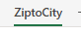

Figure 2. 26

* + 1. Find the tab in upload file. It will look like this: 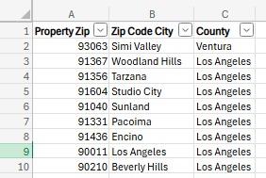

Figure 2. 27

* + 1. Hit CTRL + “-“ (minus sign), or right-click and select “Delete Columns”

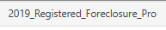

Figure 2. 28

* + 1. Go back to the tab
    2. Add this formula to **column I, row 2:** **=XLOOKUP(L2,ZiptoCity!A:A,ZiptoCity!B:B)**

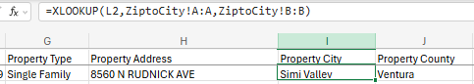

Figure 2. 29

* + 1. Hit **Enter**
    2. **Save the file.**
    3. Your new columns should look like this:

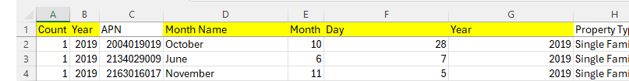

Figure 2. 30

* + 1. You have wrangled the **foreclosure** data and can now go to SAP SAC to create the Dataset for this cleaned up data.

This is the final file that you will upload into a dataset in the next step: 

Step 3: Create a Dataset in SAC

**Explain what this step is for.** This step is to create a Dataset in SAP SAC.

1. Open a web browser and navigate to SAP Analytics Cloud (SAC): <https://highereducation.us10.sapanalytics.cloud/>
2. Log into SAP Analytics Cloud (SAC) using your user credentials. The following should be your landing page.

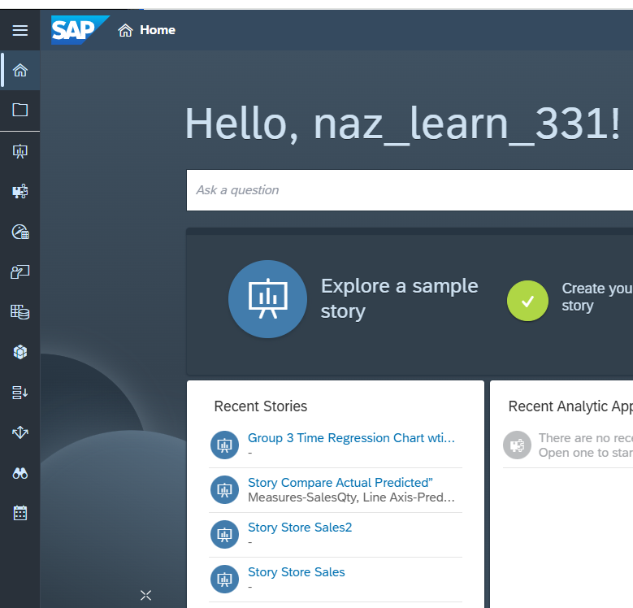

Figure 3. 1

1. Hit the **Datasets** icon on the left menu bar that looks like this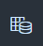

Figure 3. 2

1. Click on the paper image under **Create >> From a CSV or Excel File**

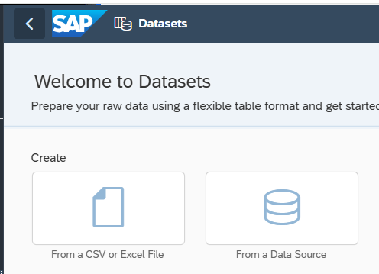

Figure 3. 3

1. The **Create Dataset From File** window pops up. Hit the **“Select Source File”** button.

Figure 3. 4

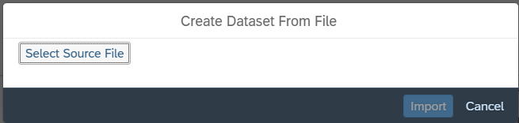

Figure 3. 5

1. Chose the “” file from where you saved the consolidated file and hit the “Open” button.
2. The **Create Dataset From File** popup window should show the source file that you selected.
3. Make sure the “**Use first row as column headers**” checkbox is checked.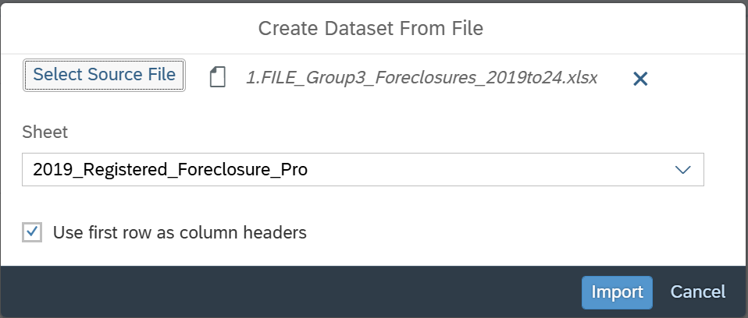

Figure 3. 6

1. **Auto-detect is the CSV Delimiter default**, do not change this. Hit the **Import** button
2. The Save Dataset window pops up next.
3. Keep the uploaded name to “**FILE_LA County_Foreclosures_2019-2024_Clean**” to become the **dataset** name.
4. Click Save.
5. The dataset will begin the upload process.

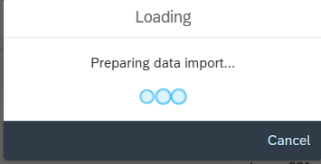

Figure 3. 6

1. Click on “Got it!” in the Sampled Data window. You should have 14,828 rows and 18 columns for the entire data set.

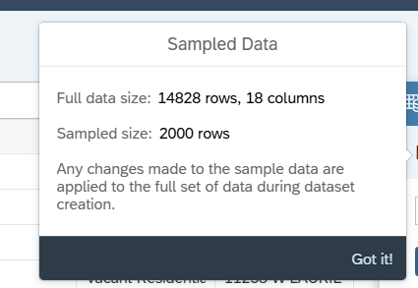

Figure 3. 7

1. In the Dataset Overview window to the right has (10) Measures and (8) Dimensions. 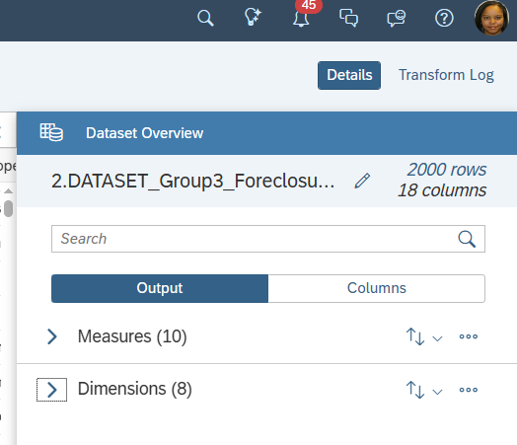

Figure 3. 8

1. **NOTE:** The only true measure for this dataset is the **Count**.
2. Change the other measures to be Dimensions: Year, APN, Month, Day, Year, Property Zip, Council District, Longitude, and Latitude. **Click on the three dots.**

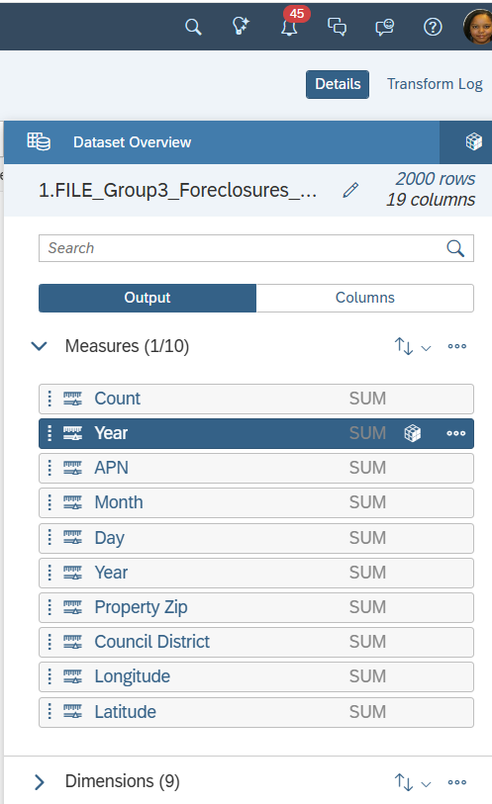

Figure 3. 9

1. Picture below shows how to change the output from measure to dimension for the first “Year” column

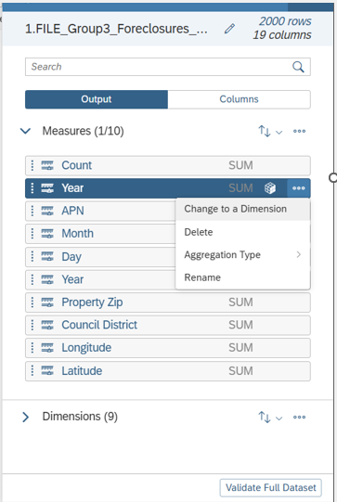

Figure 3. 10

1. After changing all but Count, your measures vs dimensions should have one Measure and (17) Dimensions:

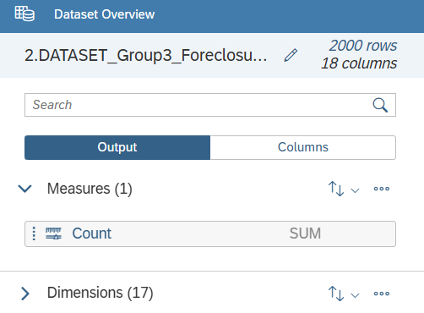

Figure 3. 11

1. Save the dataset.

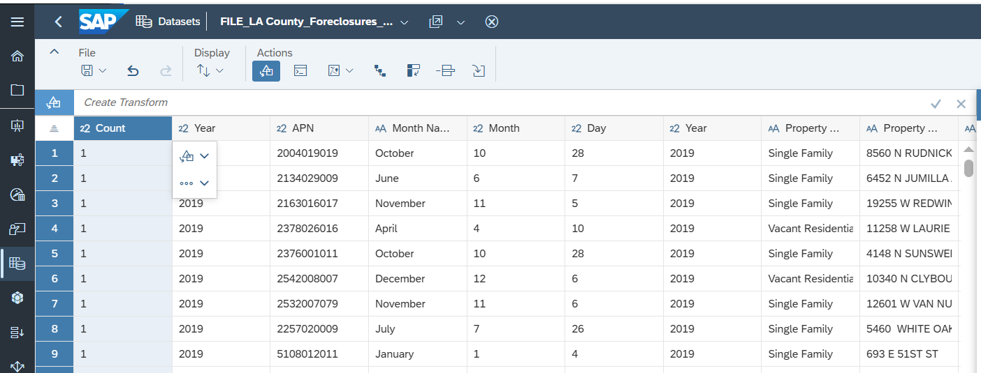

Figure 3. 12

1. Close the dataset.

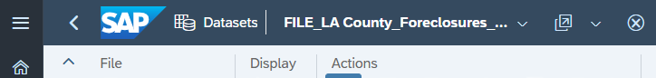

Figure 3. 13

Step 4: Create a Model in the Modeler

This step is to perform more data wrangling within the Modeler.

1. Open the Modeler to upload the Dataset into it.
2. Select “Want to create a classic model (accounts only) instead?”
3. Select “Start with data,” and select “Next”
4. Select “Dataset”
5. Select the dataset file to upload into the modeler. Don’t forget to choose the file where you want to save the new model that is almost instantly created.
6. This means it is Processing…



Figure 4. 1

1. An error message will appear.

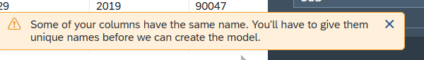

Figure 4. 2

1. You will find one issue with the dataset.

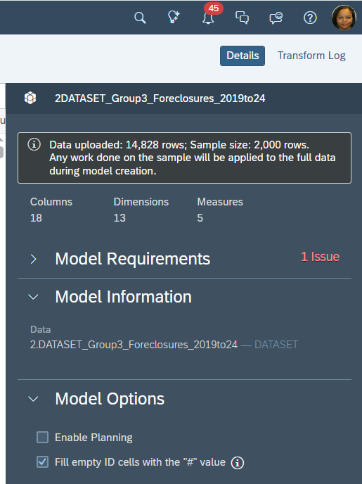

Figure 4. 3

1. There are two “Year” columns. You need every column to be unique.

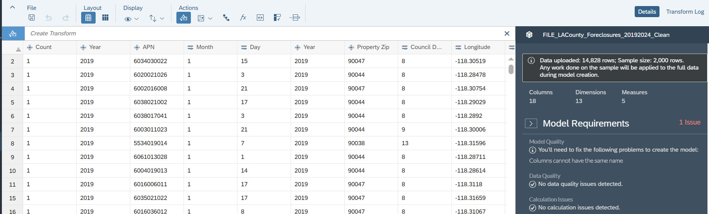

Figure 4. 4

1. The solution is to rename the first of the duplicate Year columns to “FC Year” (foreclosure reporting year).

Figure 4. 5

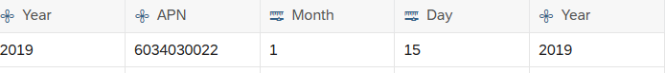

1. Rename the first column from the left “FC Year.” 

Figure 4. 6

1. The Data Quality is back to green status . 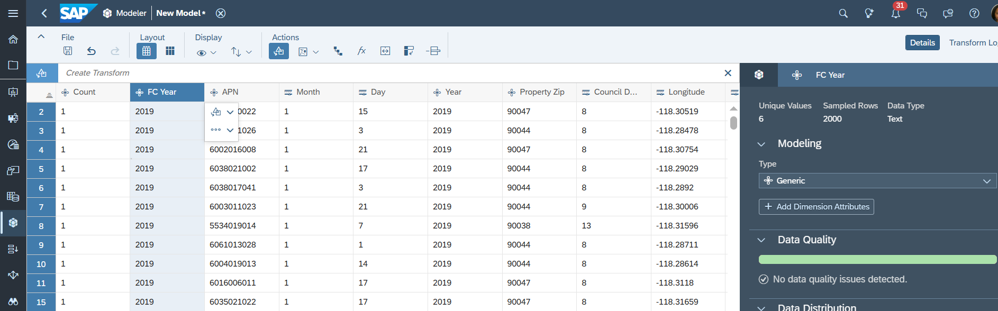

Figure 4. 7

\

1. Check the Count column. If it is a dimension, change it to a measure. 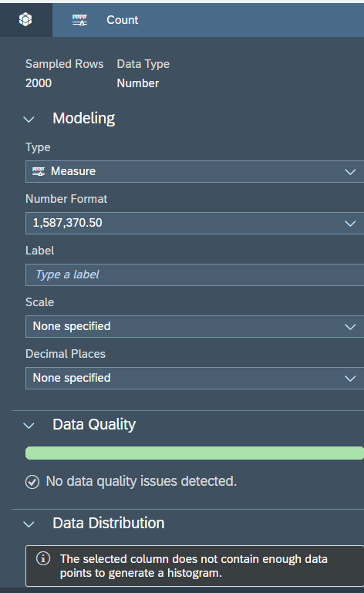

Figure 4. 8

\

1. **Concatenate the Month, Day, and Year together**
   1. Select the Month, Day, and Year columns by holding down the CTRL key while clicking on each column until the three are highlighted as depicted below.

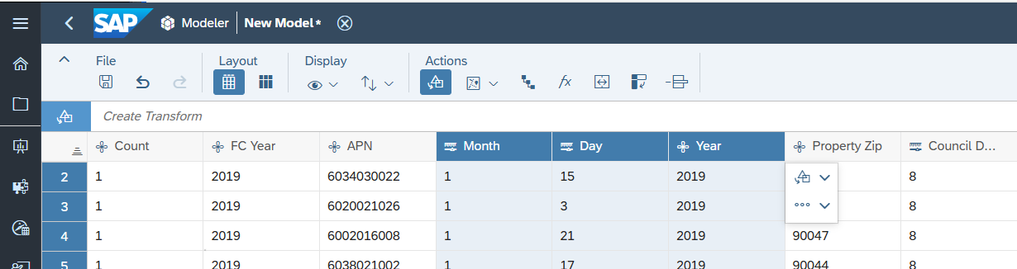

Figure 4. 9

\

* 1. Click inside the Create Transform window and select “Concatenate.”

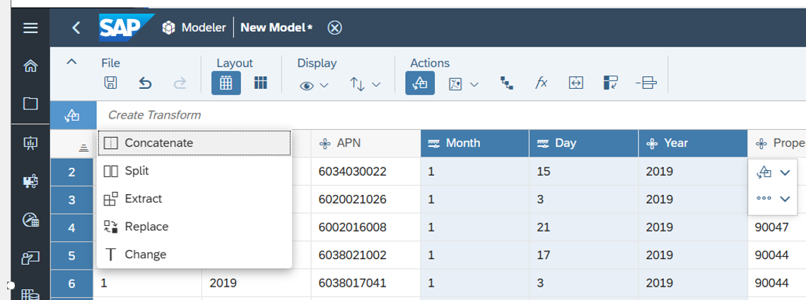

Figure 4. 10

\

* 1. Add a “/” after “using” and between the quotes. Notice the green column is a preview of the data.

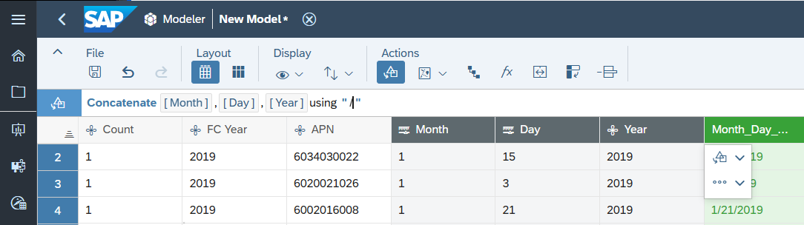

Figure 4. 11

\

* 1. Hit Enter on your keyboard
  2. The result is the formula in the newly merged column.

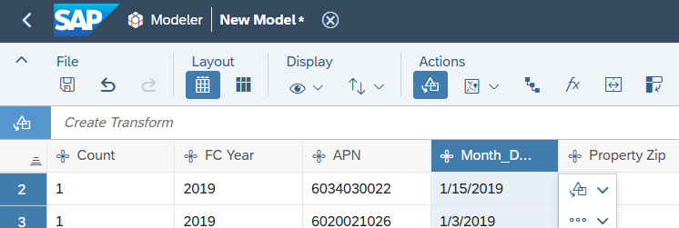

Figure 4. 12

\

* 1. Double click on the column header, and change the name to “FC Date,” hit Enter.

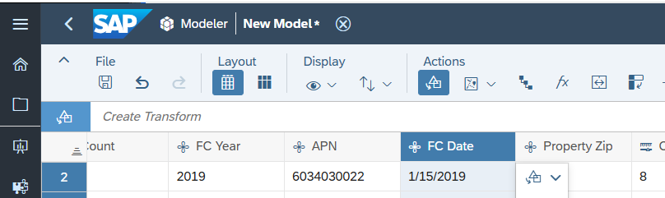

Figure 4. 13

\

* 1. Change the FC Date from a dimension to a date, make sure it is in the “MM/DD/YYYY format.

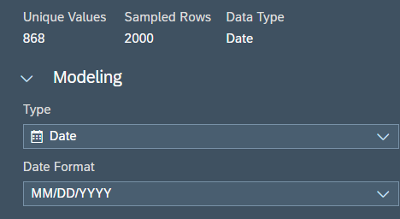

Figure 4. 15

\

* 1. One last check: check that only the Count column is a measure, the FC Date is a Date and all the other columns are dimensions.

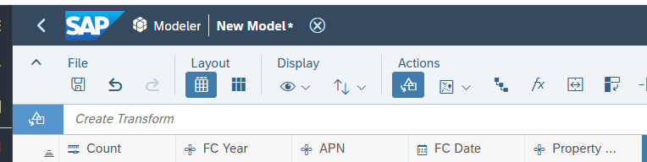

Figure 4. 16

\

* 1. Save the Model.

1. **Create the Geo Enrich Coordinates for the Heat Map.**
   1. Select the Longitude and Latitude columns. Hold the CONTROL button down while clicking on each column.

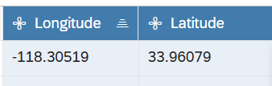

Figure 4. 17

\

* 1. Under Actions, select the Geo map button>>GeoEnrich by:>>select Coordinates.

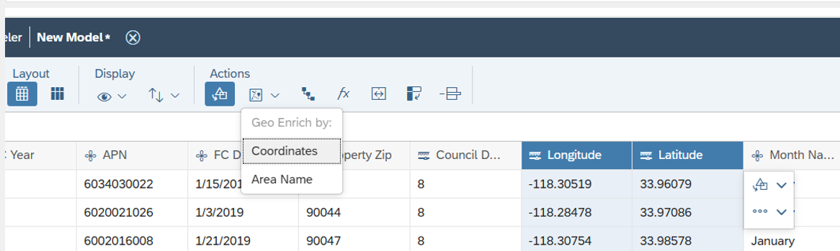

Figure 4. 17

\

* 1. In the pop-up window “**Geo by Coordinates**.”
     1. **Dimension Name** to be “FC_Loc;” have no spaces in the name.
     2. **Identifiers** are: Location ID: “blank;” Location Description: “blank.”
  2. The Coordinates **Latitude and Longitude** should be automatically populated.
  3. Hit “Create.”

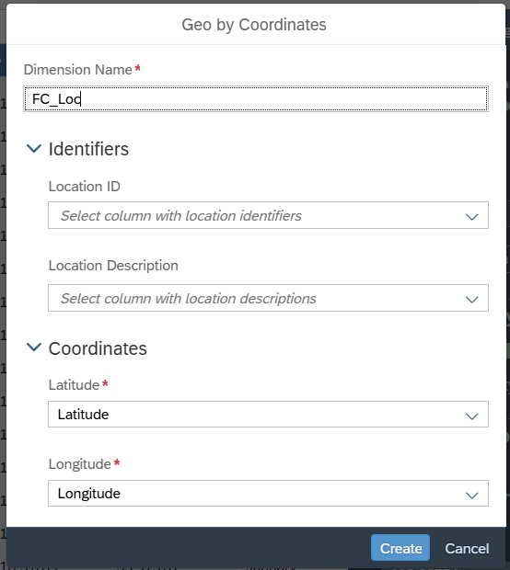

Figure 4. 18

* 1. Our newly created Foreclosure location coordinates were successful, and data quality should be green.
  2. **NOTE:** An error message in the black box reads: “The selected column does not contain enough data points to generate a histogram.” We can ignore, because we are using this column to generate bubble and heat maps, and are not using for bar graphs (histograms).

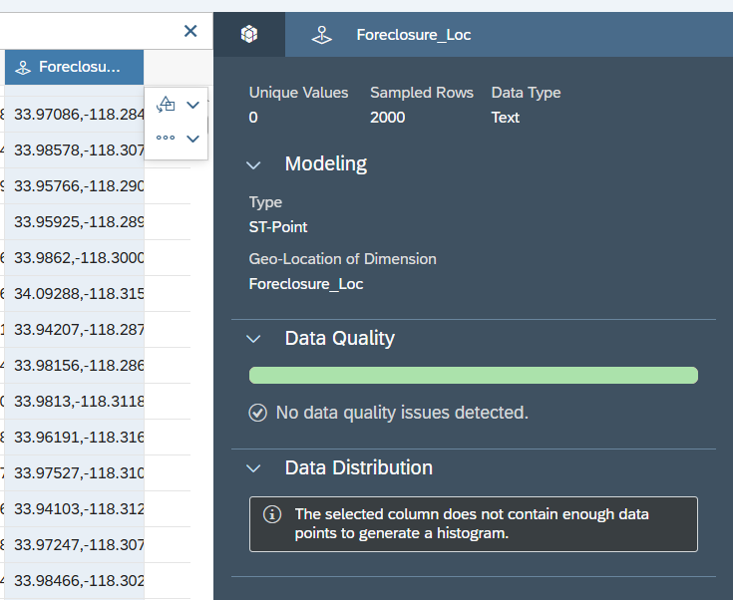

Figure 4. 19

\

1. SAVE your progress.
2. Click on Validate Data if “No issues detected” is next to Model requirements.

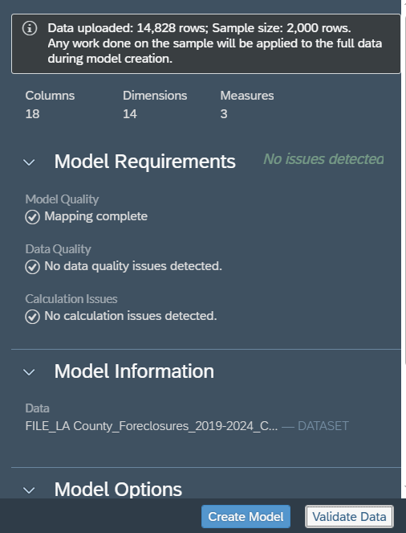

Figure 4. 20

\

1. Create the model: click on the Create Model button.



Figure 4. 21

\

1. The system will ask you a confirmation question as follows: 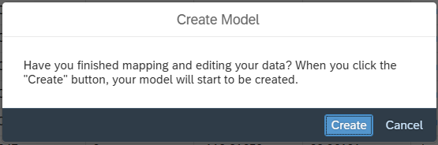

Figure 4. 22

\

1. If you are good with your data, click “Create.” If no, click “Cancel.”
2. Find the location where you want to save the Model. Rename the model to:

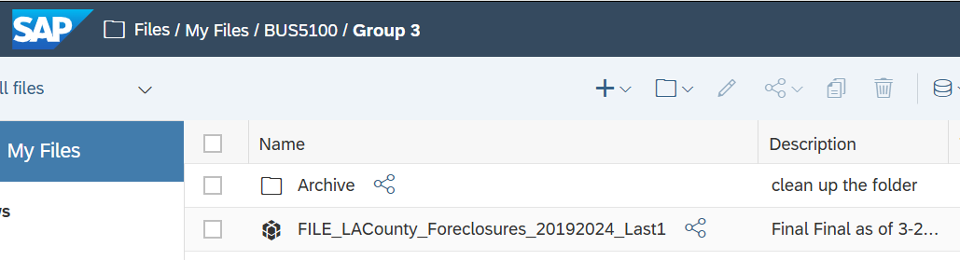

Figure 4. 23

\

1. The validation window appears. Do not close the window. Wait until the process ends.

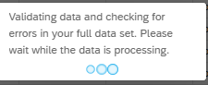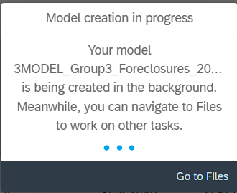

Figure 4. 25

\

Figure 4. 24

\

1. NOTE: The message boxes at the bottom will update you on the model creation status:
   1. The first will say creation has been queued.
   2. And the next will say creation is in progress.
2. Select the Model Structure Workspace, you should see the spider - we did not create any hierarchies, because duplicate and discrepancies to the data would give us red/no good data quality.

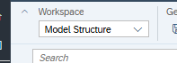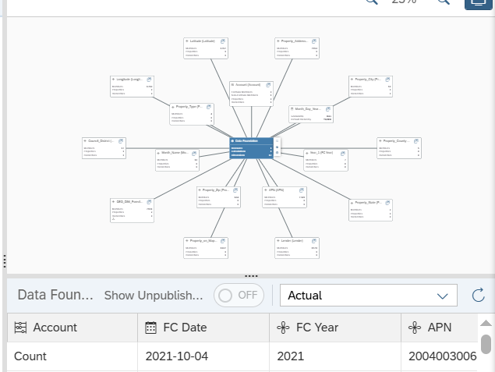

Figure 4. 27

\

Figure 4. 26

\

1. Save the Model.

Step 5: Visualization – Create a Story in Stories

This step is to create a Story using the model we created in Step 4. We will create the Top 10 Pie Chart,

Figure 5. 1

\

1. Click on the  Stories icon.
2. Select Responsive.

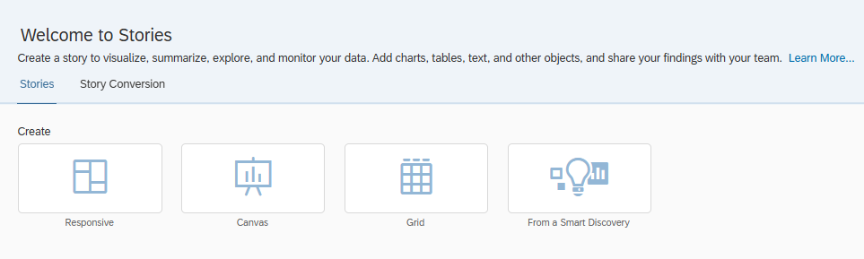

Figure 5. 2

\

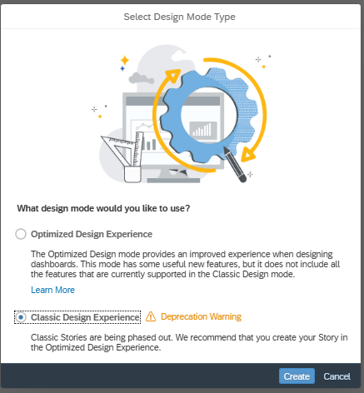

Figure 5. 2

\

1. It will land on Story, you want to import the model you created in Step 4. Click on Data. 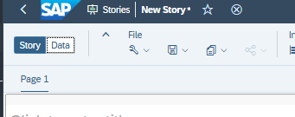

Figure 5. 3

\

1. A “Let’s add some detail” box pops up. Select the model icon. 

Figure 5. 4

\

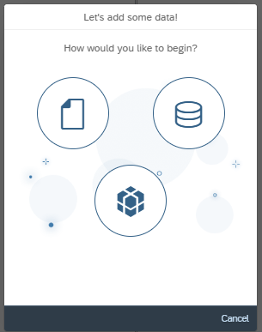

Figure 5. 5

\

1. Select the Model from Step 4: “FILE_LACounty_Foreclosures_20192024_Last1.”

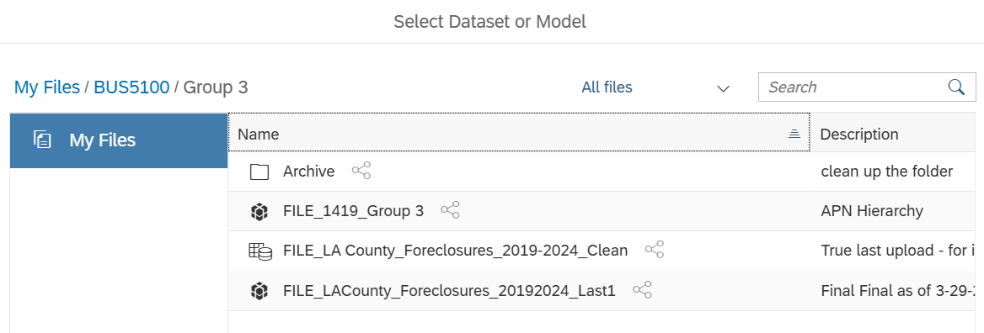

Figure 5. 6

\

1. Click on the 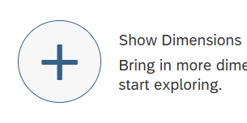”Show Dimensions” button to bring in more dimensions into the Story.

Figure 5. 7

\

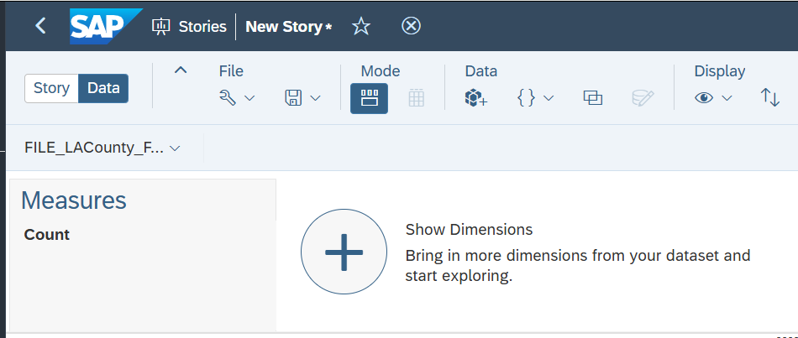

Figure 5. 8

\

1. Select “Show All” to show all of the Dimensions of the Model.

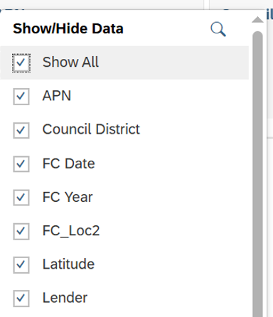

Figure 5. 9

\

1. The result view looks like this. Click back over to the Story to get started creating the charts in the next steps.

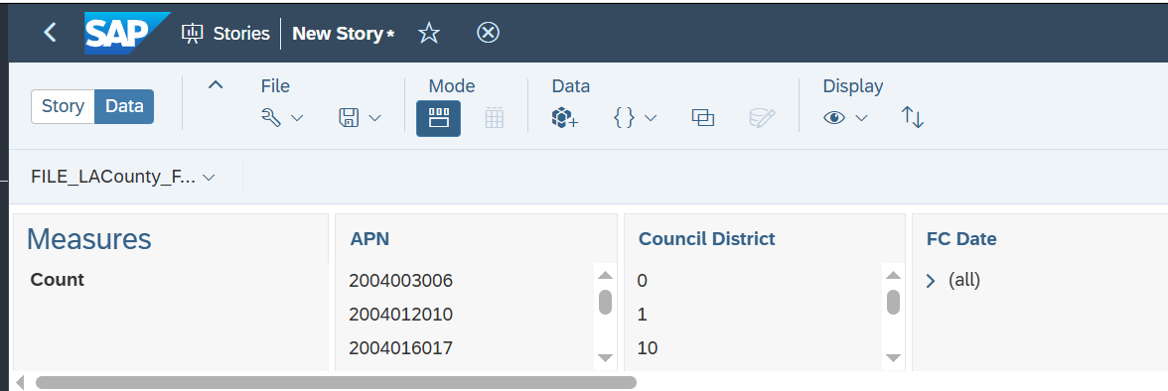

Figure 5. 10

\

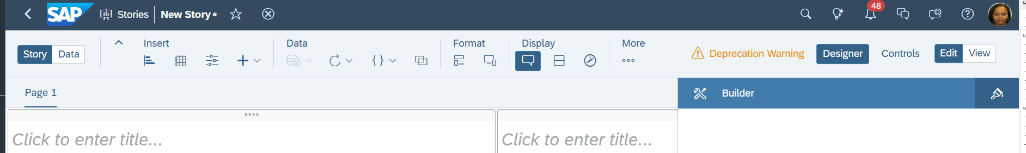

Figure 5. 11

\

1. Save the Story as **“[Group#_Foreclosures_[County]_FinalStory.”**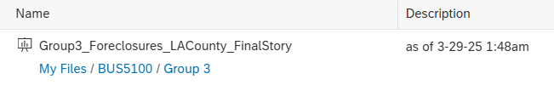

Figure 5. 12

\

1. Story Saved message should appear at the bottom.

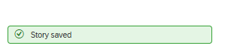

Figure 5. 13

\

Step 6: Visualization – Pie Chart

**Objectives**

In this portion of the hands-on lab, you will learn how to:

* Use the data provided to be able to create a **Pie Chart**.
* This will visually represent data as proportions or percentages, making it easy to understand the contribution of each category to the total.
* The Pie Chart will show that Los Angeles City had the highest amount of foreclosures compare to the rest of Los Angeles County.

1. Start a new Page: Responsive
2. Change from View to Edit
3. Under Insert: Add Chart

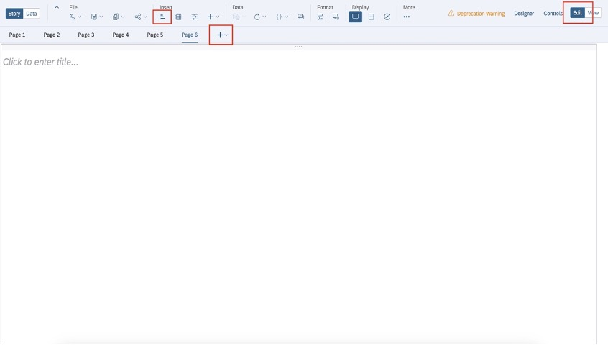

*Figure 6. 1*

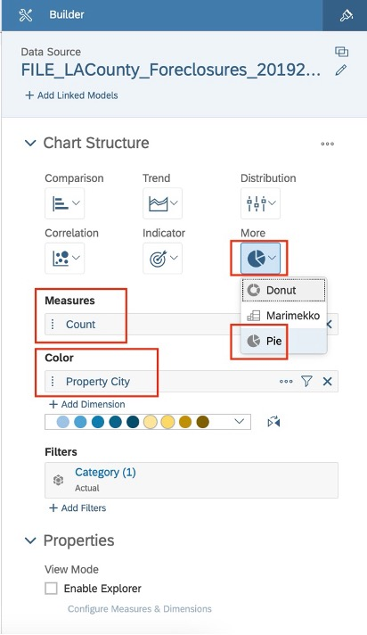

1. In Builder:
   1. Change the chart structure to pie chart selecting more: Pie Chart
   2. The Pie Chart option will be grayed out, but you can still select it
   3. Add a measure: Count
   4. Add a Dimension under color: Property City
2. The Builder should look the like Figure 6. 2
3. Save

Figure 6. 2

1. At this point in formatting, you should have a pie chart like the one shown below:

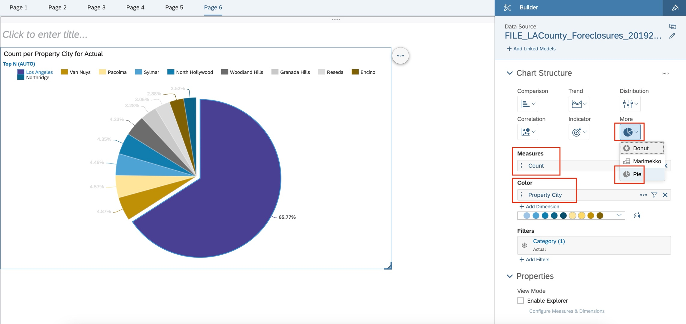

*Figure 6. 3*

1. Update Title to pie chart to the following: Top 10 Cities with Foreclosures in Los Angeles County
2. Update the Subtitle from “Count” to “Percentage”
3. Update Sort to the following:
   1. Mode: Top
   2. Value: 10
   3. Dimension: Property City
   4. Measure: Count
   5. Cross Calculation: Measure Values
   6. Version: Actual

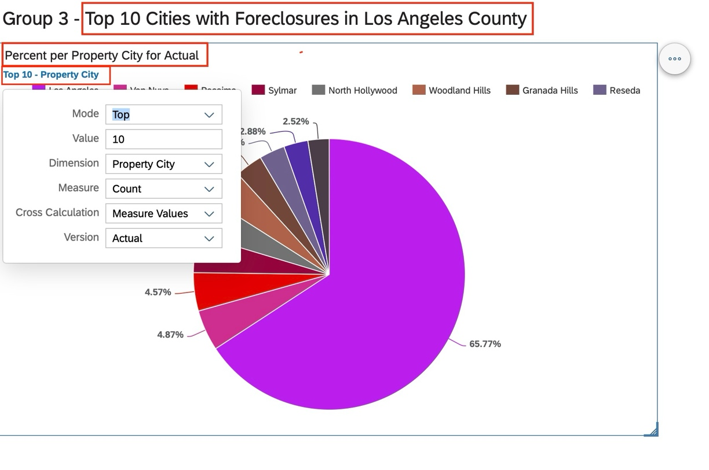

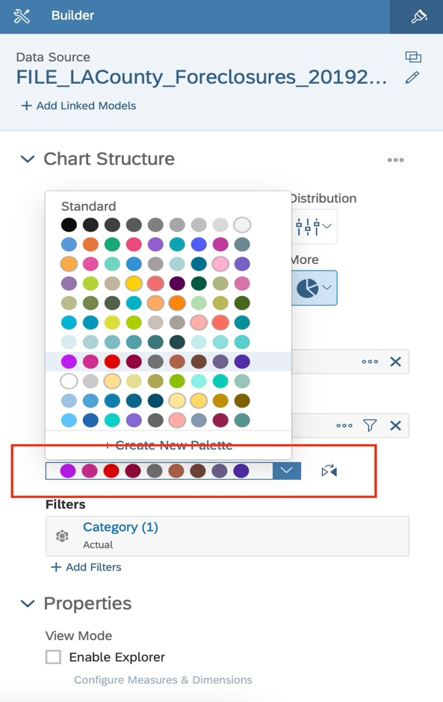

*Figure 6. 4*

1. Save
2. You can update the colors of the pie chart by selecting the following in the Builder: (Figure 6.5)

Figure 2. 5

1. Save

*Figure 6. 5*

Step 7: Visualization - Bar Charts

**Objectives**

In this portion of the hands-on lab, you will learn how to:

* Use the data provided to be able to create two **Bar Charts**.
* This will visually compare data across distinct categories or groups, making it easy to see relative sizes and differences at a glance.
* The first Bar Chart will show that the Year 2019 had the most foreclosures compared to other years.
* The second Bar Chart will show that the most common property type to be foreclosed on is a Single-Family home.

1. Start a new Page: Responsive

2. Change from View to Edit

3. Under Insert: Add Chart

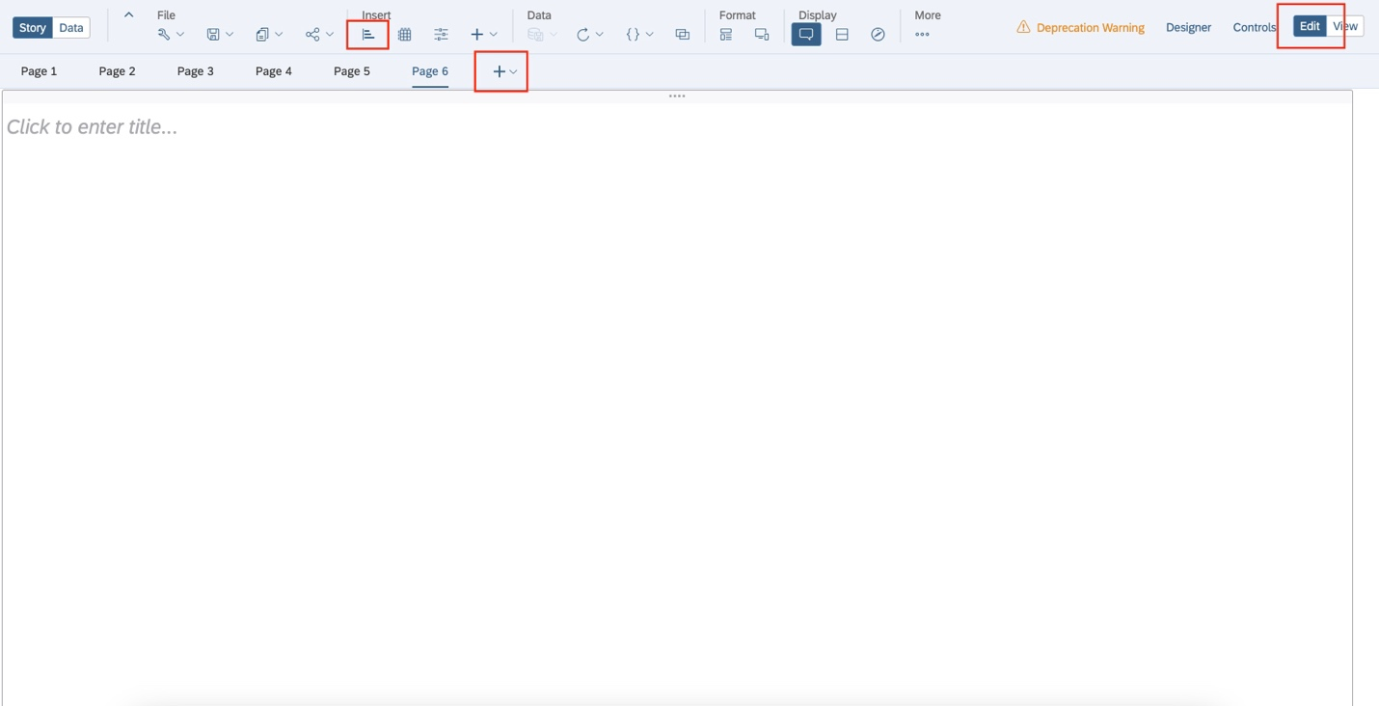

*Figure 7. 1*

1. 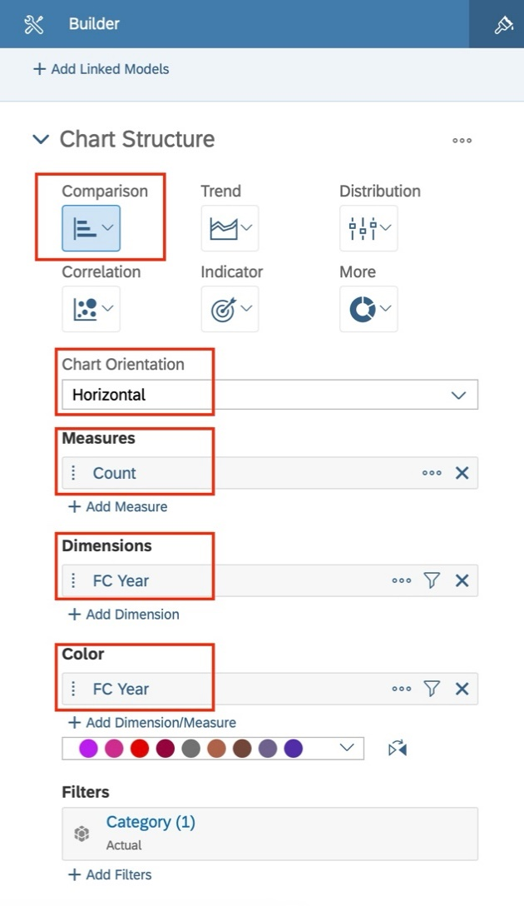In Builder:
   1. Change the chart structure to a bar chart by selecting Comparison: Bar Chart
   2. Chart Orientation: Horizontal
   3. Add a Measure: Count
   4. Add a Dimension: FC Year
   5. Colors: FC Year
2. The Builder should look the like figure to the right.  
   (Figure 7. 2)

Figure 3. 2

1. Save

|  |
| --- |
| *Figure 7. 2* |

|  |
| --- |
|  |

1. At this point in formatting, you should have a Bar Chart like the one shown below:

|  |
| --- |
| *Figure 7. 3* |

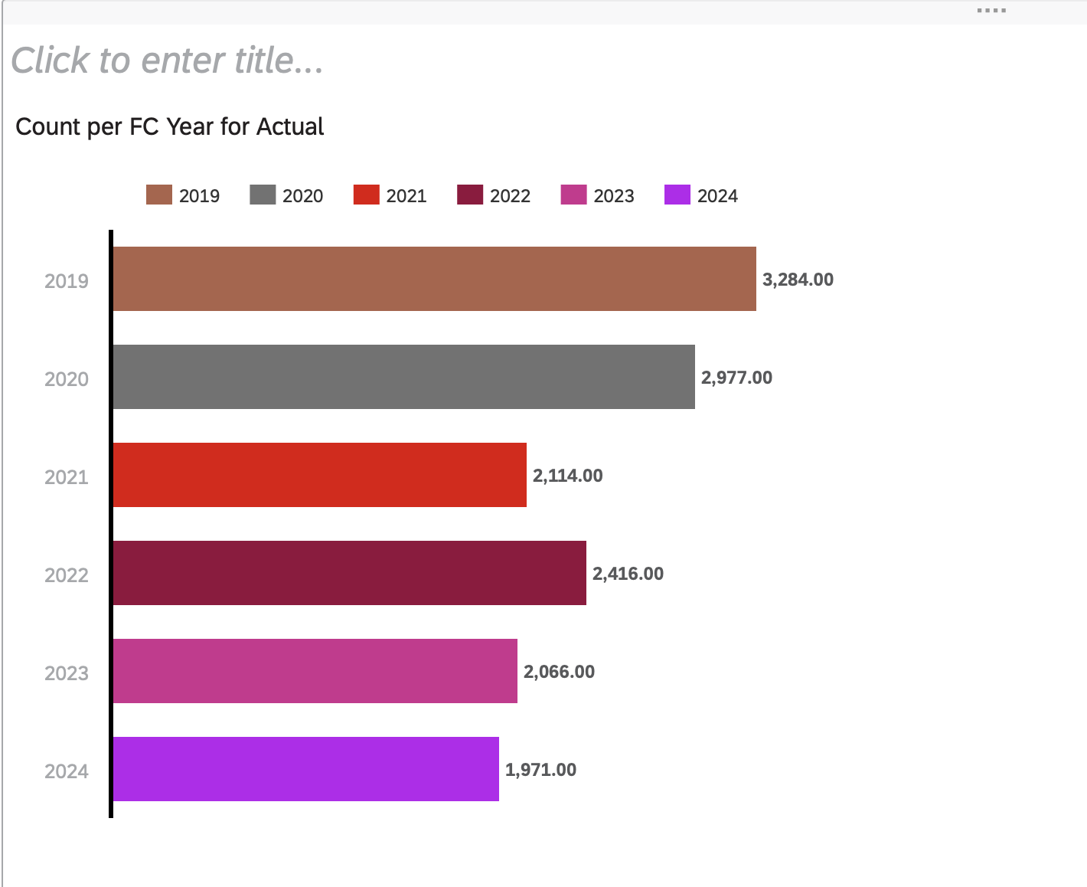

|  |
| --- |
|  |
|  |

1. Update Title to bar chart to the following: Foreclosures in Los Angeles County
2. Update Sort to the following:
   * Select the (…)
   * Select Sort
   * Count
   * Lowest to Highest
3. Save

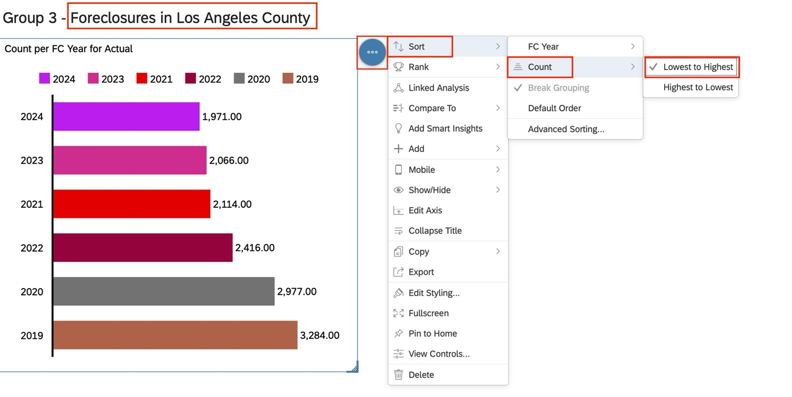

Figure 7. 4

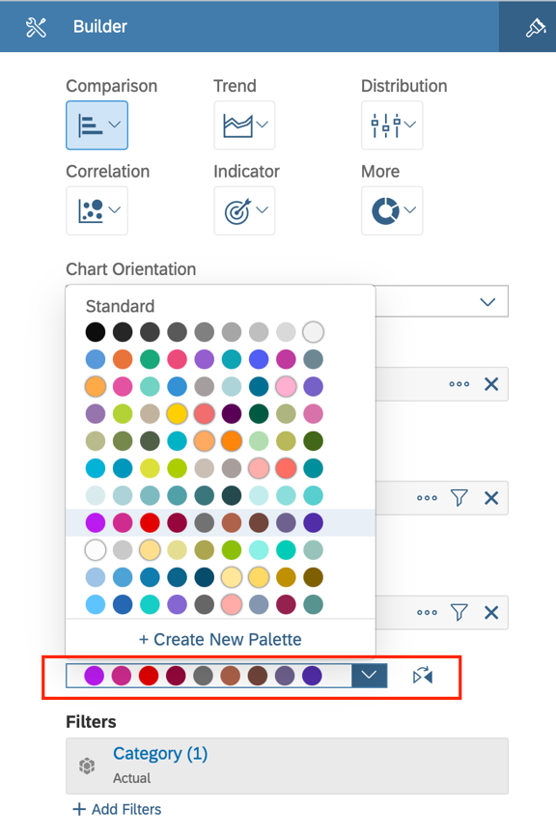

1. You can update the colors of the pie chart by selecting the following in the Builder:(Figure 7.5)
2. Save

|  |
| --- |
|  |

Figure 7. 5

13. Start a new Page: Responsive

14. Change from View to Edit

15. Under Insert: Add Chart



*Figure 7. 6*

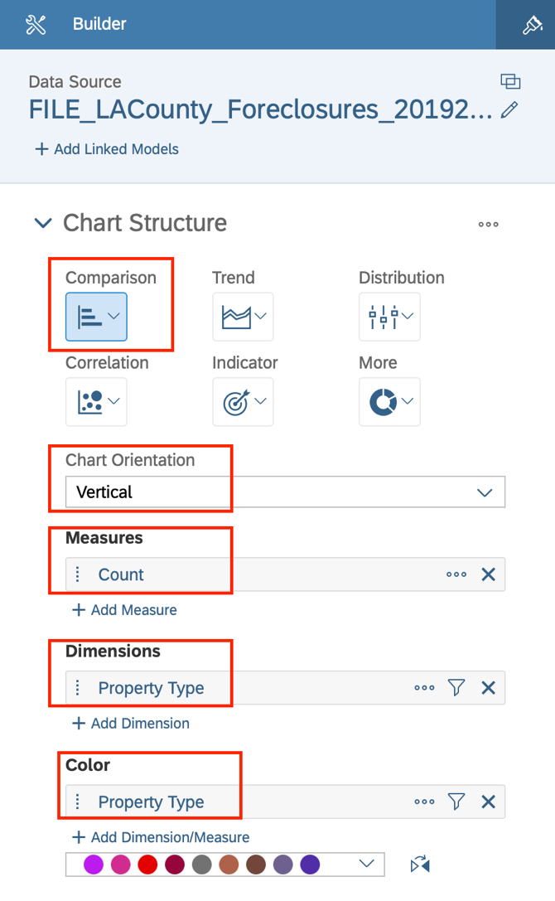16. In Builder:

* 1. Change the chart structure to a bar chart by selecting Comparison: Bar Chart
  2. Chart Orientation: Vertical
  3. Add a Measure: Count
  4. Add a Dimension: Property Type
  5. Colors: Property Type

1. The Builder should look the like Figure 7. 7
2. Save

Figure 7. 7

1. At this point in formatting, you should have a Bar Chart like the one shown below:

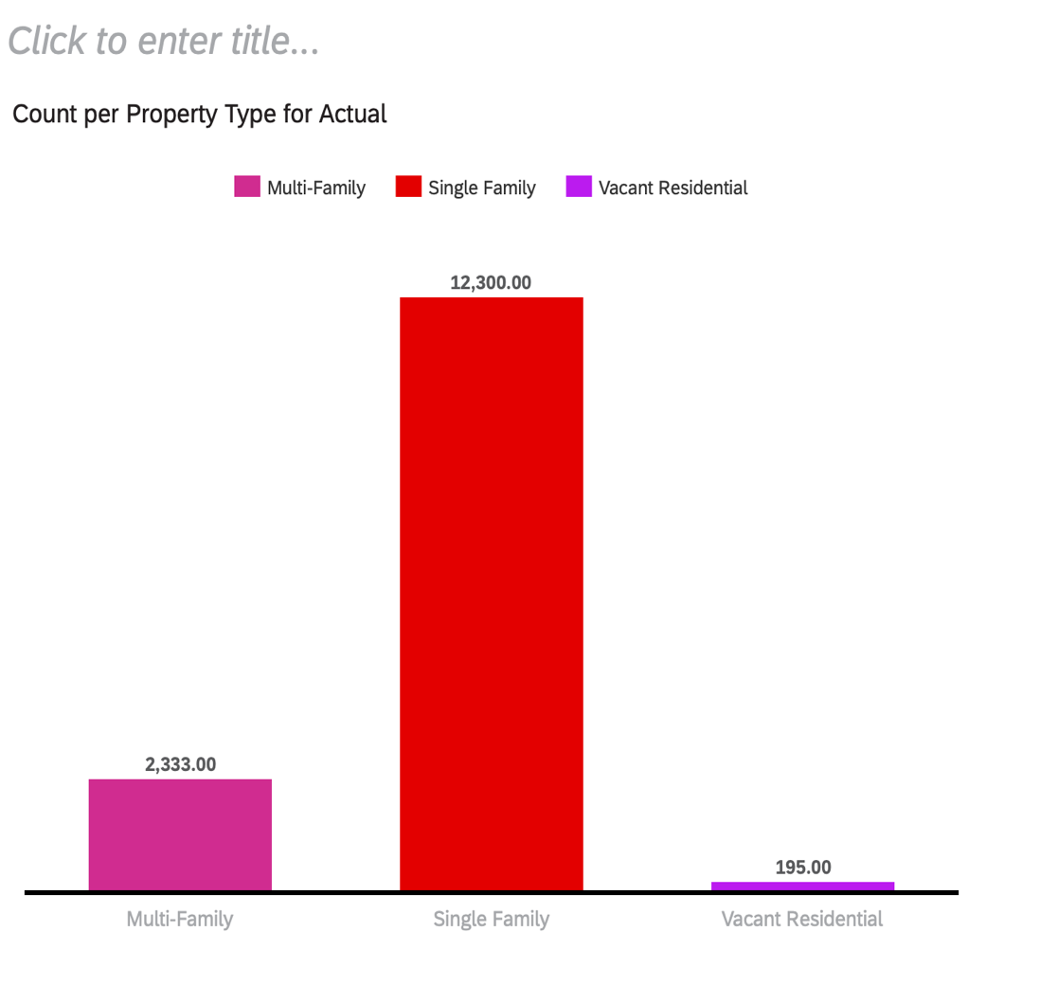

Figure 7. 8

|  |
| --- |
| *\* |

1. Update Title to bar chart to the following: Foreclosures in Los Angeles County
2. Update Sort to the following:
   1. Select the (…)
   2. Select Sort
   3. Count
   4. Lowest to Highest
3. 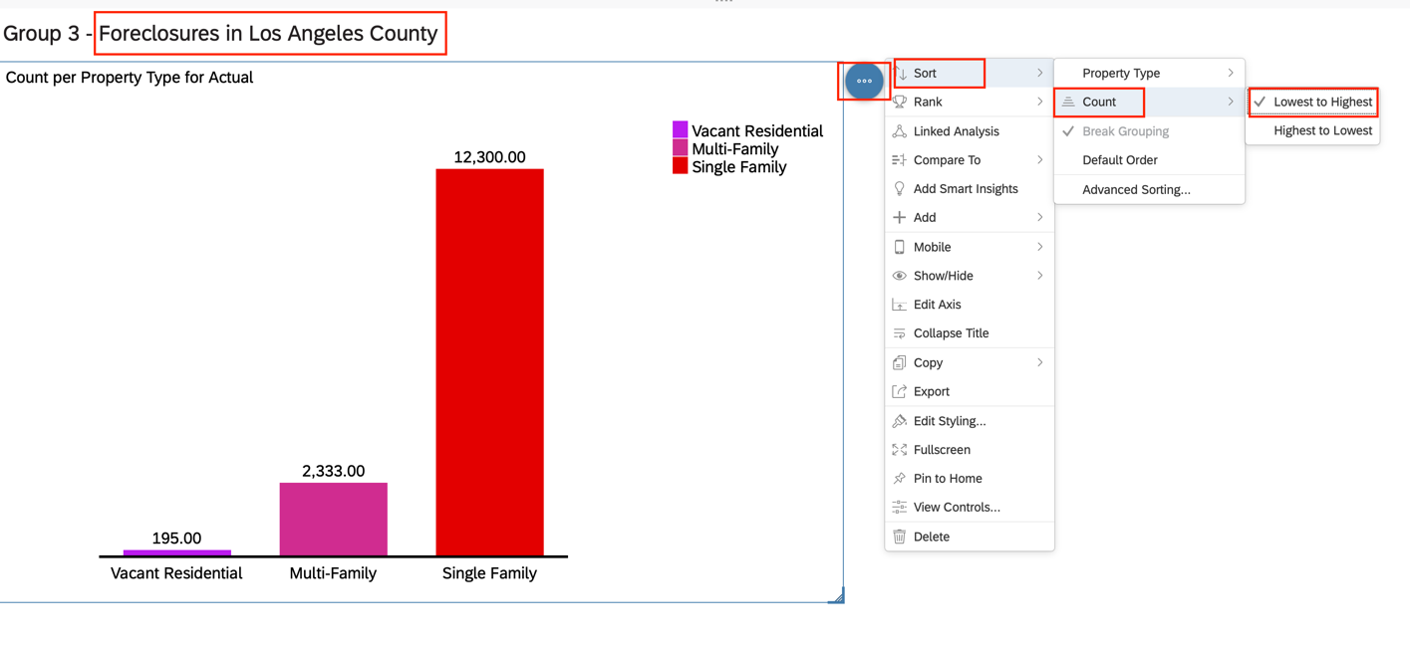Save

|  |
| --- |
| *Figure 7. 9* |



1. You can update the colors of the pie chart by selecting the following in the Builder: (Figure 3.10)
2. Save

|  |
| --- |
|  |

Figure 7. 10

Step 8: Geo Map

**Objectives**

In this portion of the hands-on lab, you will learn how to:

* Use the data provided to be able to create a **Geo Map**.
* to visualize and communicate spatial information about the world, including location, features, and patterns, in a clear and understandable way.
* The Geo Map will highlight the areas most affected and least affected by foreclosures in Los Angeles County.

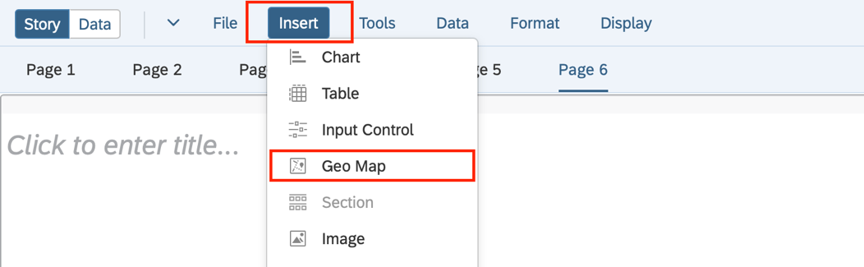

1. Start a new Page: Responsive

2. Change from View to Edit

3. Under Insert: Geo Map

Figure 8. 1

1. 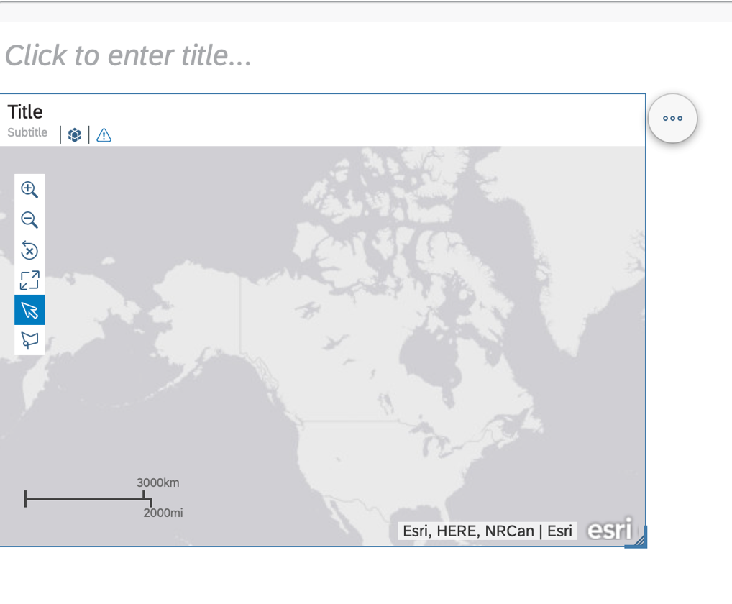Your Geo Map should look like   
   Figure 8.2

|  |
| --- |
|  |

Figure 8. 2

1. 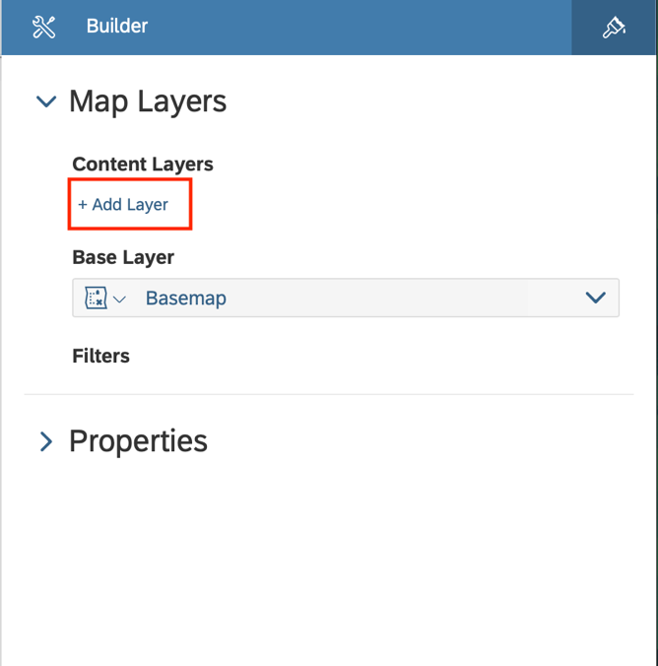In Builder:
   1. Select Add Layer
   2. Layer Type: Heat Map Layer
   3. Location Dimension: FC_Loc2
   4. Heat Map Color: Count
2. The Builder should look the like Figure 8. 4
3. The Map should look like Figure 8. 5
4. Save

Figure 8. 3

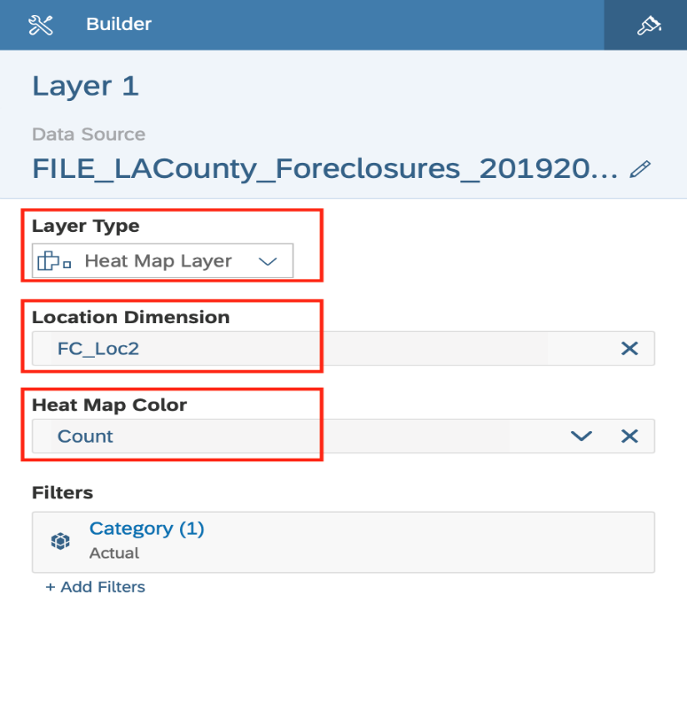

Figure 8. 4

1. At this point in formatting, you should have a Geo Map like the one shown below:

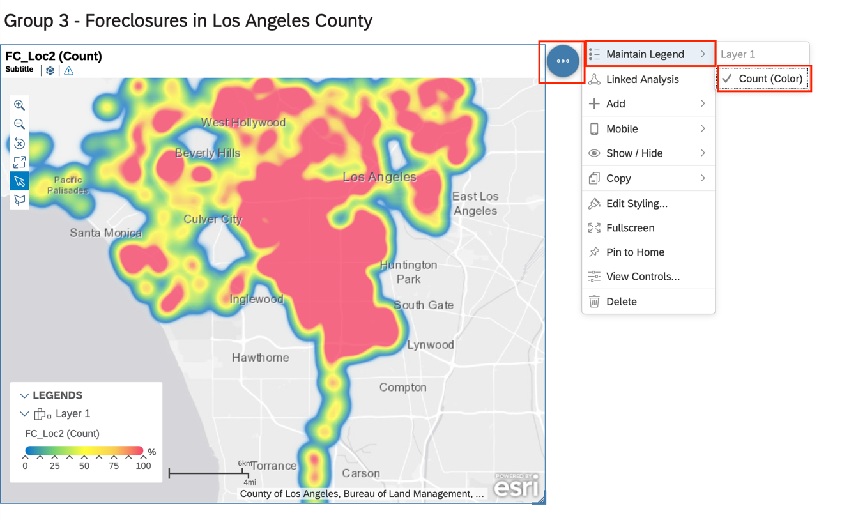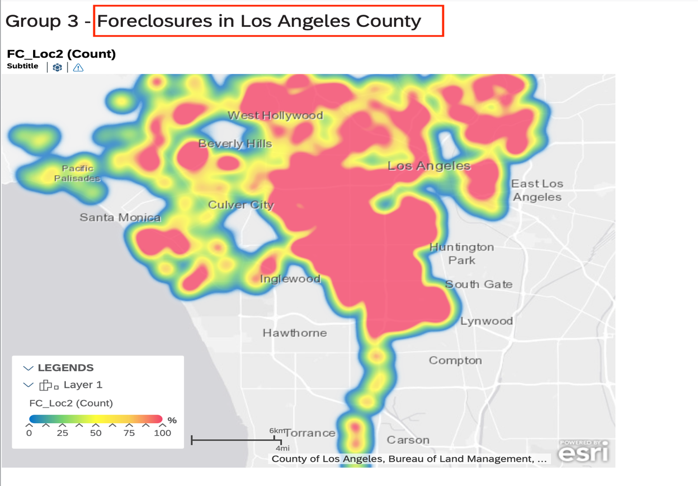

Figure 8. 5

Figure 4. 4

1. Update Title to bar chart to the following: Foreclosures in Los Angeles County
2. To add Legend:
   1. Select (…)
   2. Maintain Legend
   3. Count (Color)
   4. As seen in Figure 8. 6
3. Save
4. Your Map should resemble Figure 8. 5 above.

Figure 8. 6

Figure 4. 4

Step 9: Visualization –Time Series Regression and Forecast

This step is to create a Time Series Regression chart to show foreclosures over the years 2019-2024.

1. Set up the time regression chart
   1. Select the Trend > Time Series Chart structure from the Builder menu on the right.

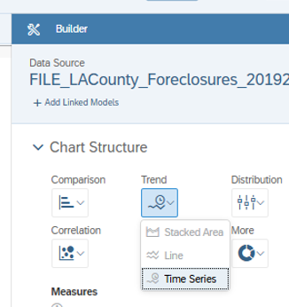

Figure 9. 1

\

* 1. Select the Measures to be **Count**.
  2. Select the Time to be **FC Date**
  3. Color is the 4th column from the bottom in the color scheme selector.

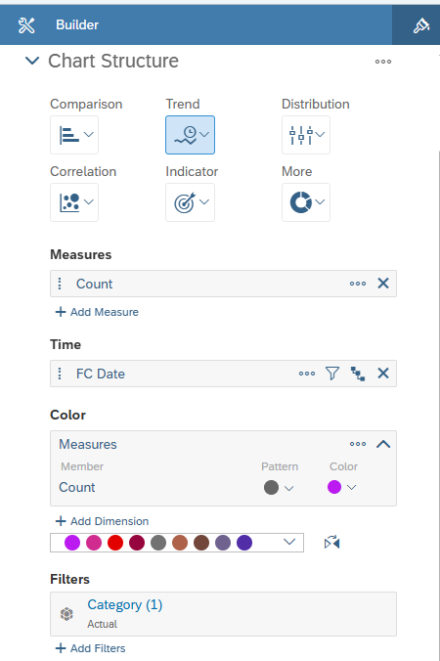

Figure 9. 2

\

* 1. The resulting Trends graph appears to the left. It is for 1 Year, and the blue box time series range selector is in the bottom right of the graph.

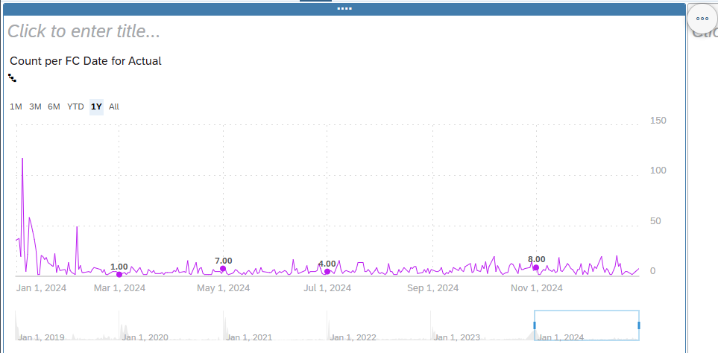

Figure 9. 3 Time Series Regression Trends Chart

1. Add the Forecast to the Time Series graph.

Figure 9. 4

\

* 1. Click on the More Options or three dots 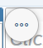 in the top right corner of the chart.
  2. Click on + Add > Forecast > Automatic Forecast as shown below. 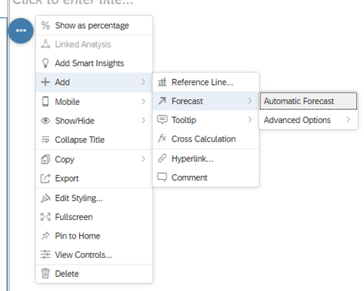

Figure 9. 5

\

* 1. You will see forecast loading in the top left corner of the graph. It’s trying to calculate the 2025 future foreclosures.

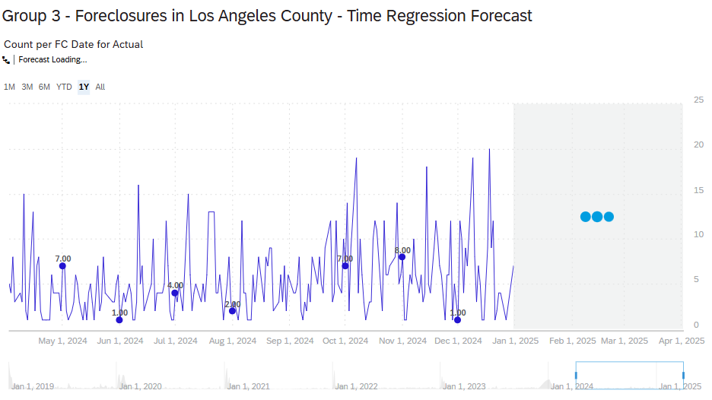

Figure 9. 6

\

1. The purple box is the forecast. Hit “**1Y**.” This is the final resulting forecasting graph. 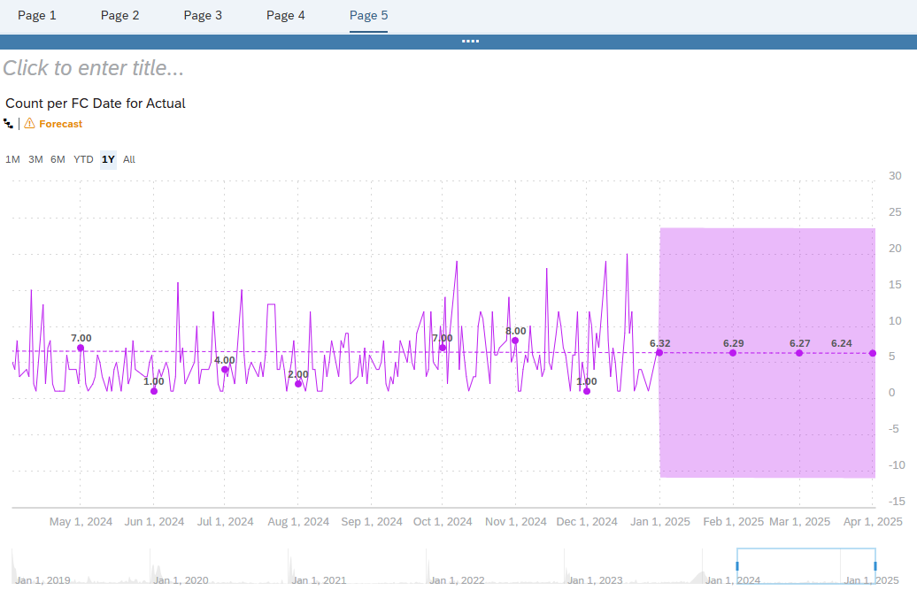

Figure 9. 6

\

1. Play around with the final forecasting graph.
2. Click the trends by day, 1 month, 3 months, 6 months, YTD, 1 Year, and All years.
3. The final forecast for future months with the **Year 1** view, is:
   1. Jan 2025 = 6.32
   2. Feb 2025 = 6.29
   3. Mar 2025 = 6.27
   4. Apr 2025 = 6.24
4. Save the story at the top by choosing **File > Save**.
5. Story is complete!
6. Share it with someone by selecting in the top File menu: Share > Share…

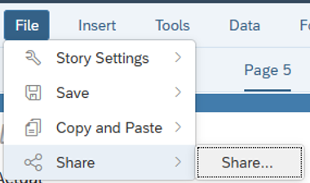

Figure 9. 7

\

1. You need to know the Username to send it.
   1. Enter the SAP Name “**naz_learn_[###]”** in the Add Users or Teams box.
   2. Change the Access to **Full Control** so that they may edit the Story.

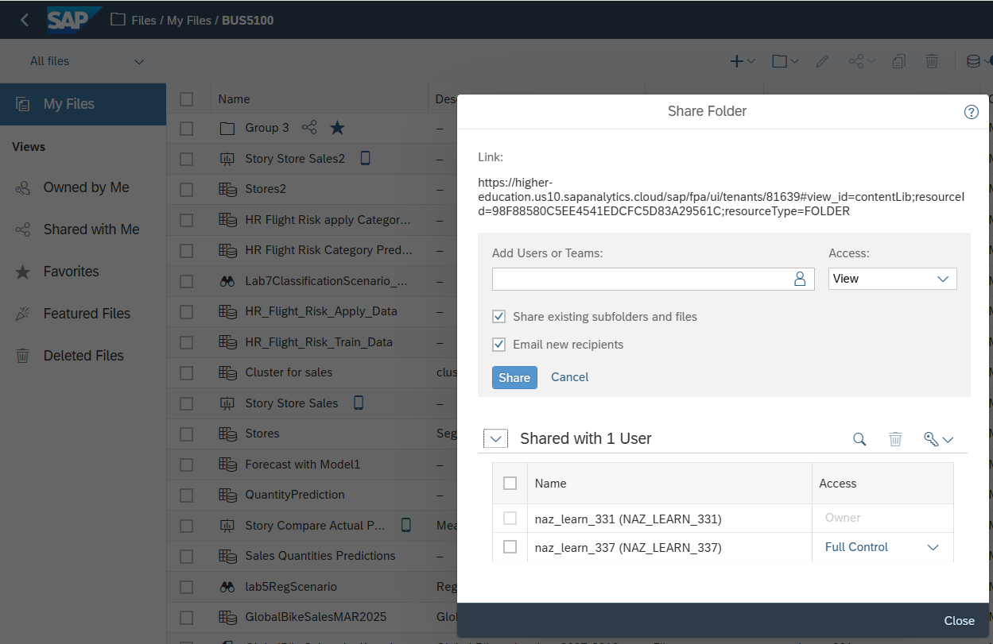

Figure 9. 8

\

**~~~~~~~~~~~~~~~~You have reached the end of the tutorial. Thanks!~~~~~~~~~~~~~~~~~~~~**

References:

* 1. URL of Data Source, <https://data.lacity.org/browse?q=Registered+Foreclosure+Properties&sortBy=relevance&pageSize=20>
  2. URL of your Github, <https://github.com/jmiramo5/team-three-term-project>
  3. Update by Woo, J.(2025); Created by Kale, N & Jones, N. “Chapter 4. Data Analysis: Dashboard and Time Series Analysis – Lab 4” <https://calstatela.instructure.com/courses/115256/files/20002474?wrap=1>
  4. SAP Help website Story Chart help,

<https://help.sap.com/docs/SAP_ANALYTICS_CLOUD/00f68c2e08b941f081002fd3691d86a7/0527de560beb4f0dbced12522815aaef.html?locale=en>